**IMPORTANT: Closing a study in myResearch IRB is permanent. If a study is closed, it cannot be re-opened, and a new study will need to be submitted.

You should see all of your available studies in the All Submissions section of your IRB page (see #2 below for instructions for searches in myResearch IRB). If you do not see one of your studies, please review the following points:

- If you are the approved Principal Investigator (PI) in myResearch IRB but you do not see one of your studies, send an email with the IRB study ID number to ORC_OVPR@stonybrook.edu for assistance.
- If you are not the PI and you do not see one of your studies:
  - If you do not have access but the study is available to the PI, you must ask the PI to assign you as the Primary Contact. This requires simply accessing the study and clicking “Assign Primary Contact” in the left navigation area to select your name. This will give you immediate access to the study in myResearch IRB and you will receive all notifications related to this study. Note: The primary contact can be changed as often as necessary by any study team member.
  - If the PI also does not have access to the study, send an email with the IRB study ID number to ORC_OVPR@stonybrook.edu for assistance.
** Studies with an external IRB as the IRB of record should also be closed in myResearch IRB.

Instructions:
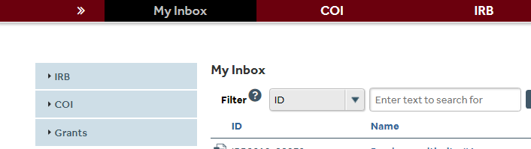
- Click on the IRB tab.

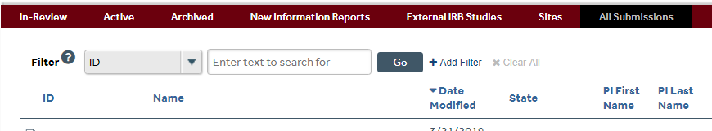
- Use the ID filter in the drop-down menu to search for your study using the IRB study ID number. Search under the All Submissions tab. Notice that you can also filter by the study name or the PI first/last name.

- Select the study title. This will route you to the study’s main workspace with several actions
available to you on the left side of the screen. Select Create Modification/CR.
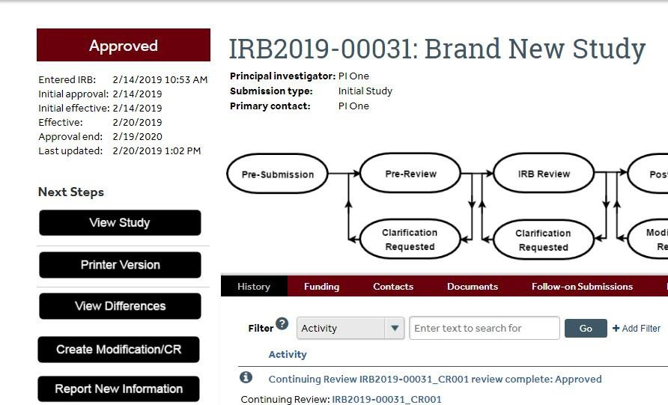

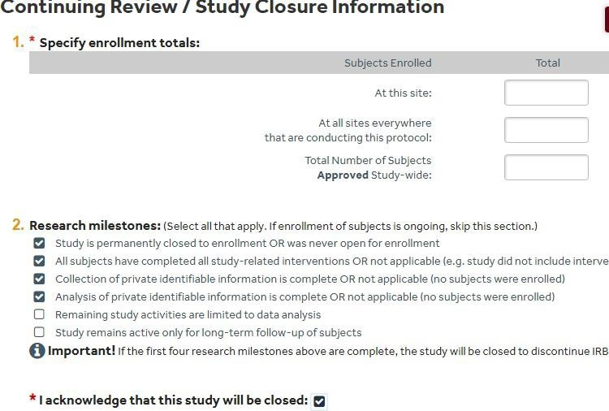
- Select Continuing Review.

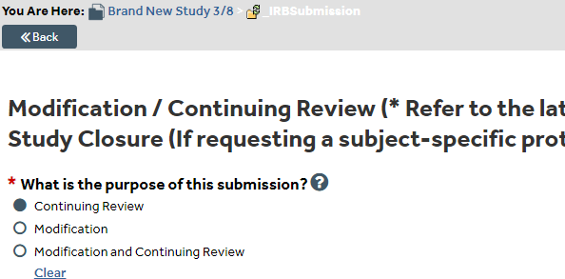

- Complete the Continuing Review page. Confirm the first four research milestones and that the study should be closed upon receipt by the Office of Research Compliance.

- Check boxes and add documents for questions 4 and 5, as applicable. For question 5, click Add to upload the following for the last subject enrolled in the most recent approval period (as applicable).

  - Last signed consent/parent permission/assent form (redacted version)
  - Last completed inclusion/exclusion criteria checklist (redacted version)
- Select Continue. You will be directed to a Final Page that mentions ancillary reviews. Ignore these requirements, which are not applicable for closure submissions.

- Select Finish. Only the person listed as the Principal Investigator (PI) will see the option to Submit the closure application for review. If someone other than the PI creates the submission, the Add Comment option can be used to send a comment/email notification to the PI that the application is ready for review/submission. NOTE: The submission has not been submitted for closure until the PI submits the study and it enters Pre-Review.
